Stella Fantasy Raises $6M USD to Launch NFT-Based Fantasy RPG Combat Game

By Trent Rhode

September 14, 2022
Ring Games announced the closing of a private funding round on Monday that raised USD $6 million for the launch and ongoing development of its game Stella Fantasy, an RPG combat game with NFT integration on the Binance Smart Chain (BSC).
“We would like to introduce a genuine 'Play and Earn' game for global gamers within this year,” said Ring Games CEO Jooho Yun in a September 12 news release.
Krust Universe, a tech company incubator and blockchain development company, was a lead investor in the funding round. The company is currently developing a metaverse-focused blockchain ecosystem called Klaytn.
According to the release, Krust Universe wants to nurture promising global projects “which could contribute to the development of (the) Klaytn ecosystem.”
The game, built with the Unreal 4 engine, will use both BSC and Ethereum at launch, according to its official Discord channel. The development team wasn’t available prior to publication to comment on details, however, or whether the game would eventually switch to the Klaytn blockchain.
The game’s whitepaper notes that: “NFT games in the current market seem insufficient in terms of being ‘games’ themselves.” By contrast, Stella Fantasy aims to “break away from the outdated graphics and simple gameplay mechanics prevalent in the existing NFT game market to create (a) more complete and full-fledged game.”
Tradeable NFTs for the game will come in the form of characters, equipment, and other loot found, earned, and crafted during gameplay, all of which will be held in players’ game-connected wallets.
Ring Game’s Jooho will be giving a talk about Stella Fantasy on September 15 at the upcoming Binance Blockchain Week Paris 2022, which takes place from September 14-16. Stella Fantasy is the only Web3 game featured among the five projects that will be showcased at the event.
An NFT pre-sale of two types of limited characters for the game will begin on September 14, and minting will take place on September 14 and 15 on the Stella Fantasy Marketplace. The NFTs will be sold for BNB tokens and will be available exclusively during the presale.

CroSwap DEX Launches With Strong Volume in First Days
By Trent Rhode
September 30, 2022
CroSwap DEX, the backbone of a new DeFi suite for Cronos, launched on Sept. 26 and is seeing strong volume for a new Decentralized Exchange (DEX) in a bear market.
Trading volume over the first 24 hours reached over $100,000, which is comparable to many other DEXes that have been around much longer. Total volume sits at $205,000 as of Sept. 29.
SwapV, CroSwap’s Head of Development, said the team has a lot more planned for the CroSwap ecosystem, with a two-year roadmap that aims to make CroSwap stand out from other DEXes.
“Our DEX is already unique since our code was written by our team, it’s not just a regular fork,” he said. “All of our products are utilizing EIP-2535 and are very transparent. We also integrate unique products such as achievements, education, a migration tool, contract/audit services, bridges, and games. We are not going to stop until we create the perfect one-stop-shop DeFi environment for the Cronos network.”
SwapV went on to say that incentivizing users to increase Total Value Locked (TVL) in their network is a key goal of the DEX and its ongoing development.
“We want to try to get as much TVL as possible on the exchange and continue to introduce new additions into the ecosystem that allow that to happen,” he said. “The larger liquidity that we can raise - the better off we are when the market turns around and the more stable our environment will be for our community.”
To begin, CroSwap will incentivize users to lock their tokens within the CroSwap ecosystem through Liquidity Pools and Yield Farms. Both services will allow users to stake their tokens to receive rewards based on the amount they stake relative to other users.
Liquidity Pools launched on Sept. 29 while Yield Farms are set to launch in the coming days. This will be followed by “Harbors” later, which will allow users to easily implement different yield farming strategies.

What Is CroSwap:
CroSwap is in the process of launching a suite of Decentralized Finance (DeFi) services for the Cronos Network, including the CroSwap DEX, an NFT staking platform, and DeFi educational tutorials.

FEG and ROX Tokens to Merge in Preparation for New SmartDeFi Platform Launch
By Trent Rhode

September 15, 2022
FEGtoken will soon be merging with ROX token in preparation for the Q4 2022 rollout of FEG’s latest iteration of its SmartDeFi ecosystem.
ROX token, used initially to launch asset-backed tokens, and the FEG token, the main token for the FEG ecosystem, will be merged to simplify the ecosystem while adjusting tokenomics, according to FEG’s website.
“The commonality of the entire ecosystem is that it will revolve around the new (FEG) token and provide a number of passive income streams while staking,” explained RTRcrypto, Global Project Manager of FEG, in a BSC News interview.
The new expanded ecosystem is currently in late-stage development according to FEG team members. Recently, the Beta version of the DEX and other components of the ecosystem were taken offline for additional development and third-party auditing.
Components of FEG’s SmartDeFi ecosystem include:
FEG Token: the governance token for the project for the ecosystem, which can be staked by holders to collectively earn 2% of network transactions. FEG tokens are and will continue to be on both the Ethereum and Binance Smart Chain (BSC) blockchains.
FEG will also be reducing the total amount of tokens to “make FEG more attractive for investors and CEX’s” as noted on FEG’s website. When tokens are migrated, users will receive the same percentage of circulating tokens they have now.
FEGex Decentralized Exchange (DEX): Located at Fegex.com, the FTW DEX will allow users to trade directly between wallets without giving up control of their assets.
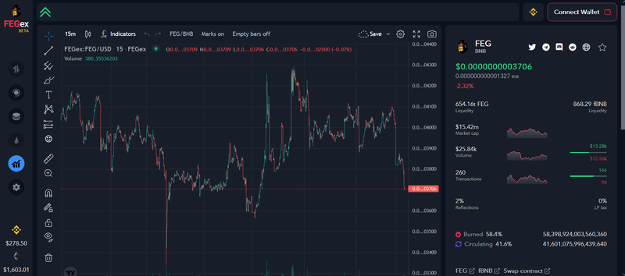
The current BETA FEGex Decentralized Exchange.
Custom Aggregator: The custom aggregator will run alongside the DEX and connect to multiple external DEXs to fetch the best price for a given trading pair.
“Note that the aggregator will have fees of the DEX that the purchase or sale is routed through, yet there is no fee that comes to our ecosystem from it,” remarked RTRCrypto.
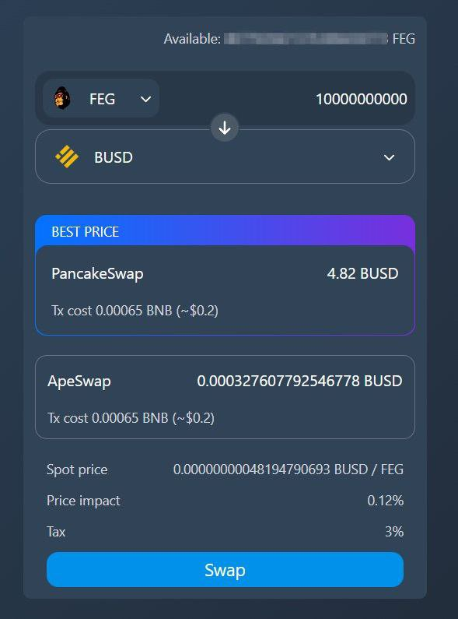
A mockup of the custom aggregator.
SmartDefi (SD) Launchpad: A tool for creating new tokens on the BSC or Ethereum blockchains. This will include an asset backing function where, when an SD token is created, a separate token can be chosen as its backing asset (e.g. BNB).
FEGTrack: A mobile app created for FEG holders to monitor their BSC staking assets and values.
Grafene Wallet: the Grafene wallet incorporates two-factor authentication (2FA) directly on the blockchain, making it much harder for attackers to steal funds even if they have a wallet’s private key.
After internal testing is completed for the various SmartDefi products and services, third-party auditors will review all smart contracts for the new ecosystem, RTRCrypto told BSC News.
FEG token holders will find the migration tool at fegtoken.com when it’s ready, while ROX token holders will have the new tokens airdropped to them.

Animal Farm V2 Launched Nov. 1 After Delays to Increase Security
By Trent Rhode
November 3, 2022
Animal farm's V2 yield farm by Drip Network has launched after auditing and security fix delays, with additional security measures also announced.
Version 2 of Animal Farm’s yield farm by Drip Network launched on Nov. 1 after auditing and security fix delays pushed the timeline ahead from Oct. 18.
The platform finalized an audit by smart contract auditing firm Truth Security on Oct. 28 that analyzed 21 contracts for security vulnerabilities. The firm found four low low-severity issues, 1 medium-severity issue, and three unspecified-severity issues. All issues were resolved prior to launch.
The team also announced additional security measures via social media on Oct. 30, writing that after launch, they would be delaying some important ecosystem change requests to some smart contracts for 48 hours after each request is made:
"Most of the variables are immutable but ... the variable changes we can make to add partnership vaults, add a new pool, add lending options, it takes 48 hours after the transaction is placed for the function to be called and the changed (sic) to go live. So everyone can see that change is going to happen before it does, days in advance."
The platform’s total value locked (TVL) was around $100 million as of publication, while the BUSD in the rewards vault totaled almost $292 million. Staking and liquidity pools are all showing APRs above 100% for assets like BTC, BUSD, ETH, WBNB, and more.

What Is Drip Network:
Drip Network is a deflationary daily Return On Investment (ROI) platform built on BNB Chain. The innovative platform, developed by CEO Forex Shark, a renowned name in the DeFi space, works with a unique mechanism that gives users up to 365% ROI.
Additionally, the protocol, in association with Animal Farm, its native Yield Farm, rewards users for adding liquidity. Users add liquidity in Drip and lock them in Animal Farm to get incentivized.

SecondLive's Wearable NFT Tool Gobeti Dresses up the Metaverse
By Trent Rhode

September 13, 2022
SecondLive, BNB Chain’s most popular metaverse project, has recently shared more details about its continuing development of Gobeti, its tool for creating 3D avatar clothing—both for SecondLive and for export to Non-Fungible Token (NFT) marketplaces or other metaverse worlds.
Gobeti, which released version 2.0 on Aug. 26, allows users to easily edit the pattern, colors, and shading on various types of clothing, including different types of shirts, bottoms, and shoes, and export them as standardized 3D files.
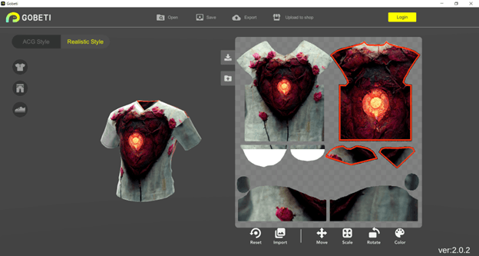
The author’s Gobeti 2.0 experiment using an image created with the Midjourney AI art generator.
SecondLive’s Gobeti R&D Director “Vento” said in an interview with BSC News that future proofing Gobeti is a major goal of the project. For example, Gobeti is being designed to be compatible with widely used AR, VR and XR wearable technical standards.
“Many people have felt the revolutionary changes in the 3D experience brought by XR wearables. Such technical innovations will be indispensable for user communication and the promotion of original content. The ultimate goal of Gobeti remains the same: to place 3D digital assets in a virtual 3D space and provide users with a completely virtual experience,” said Vento.
New features in Gobeti’s 2.0 release include:
- The ability to switch between clothing gender types with a single icon click.
- The ability to download textures to create content locally, which is useful for downloading blank textures from Gobeti that have basic 3D shading, working on it in an image editing program, and then re-uploading.
- A realistic clothing type: an option to switch between “ACG” (Animation, Comics, and Games) type clothing and more realistic clothing.
- The ability to upload multiple versions of the same garment to SecondLive.
“More than 90% of operations can be done by clicking and dragging the slider,” a Sept. 6 SecondLive article about the project noted, highlighting the fact that “most current tools in the market require other professional 3D design software for clothing mapping,” while Gobeti does not.
Vento said that a future version of Gobeti will allow users to create 3D interactive content in real-time and will incorporate AI speech recognition and motion capture technologies.
“With recent technological advancements in fields such as image recognition, motion capture, and 3D model skeletal animation ... users with no background in 3D graphics can now create full 3D graphics,” he said. “User-created 3D interactive content is at the heart of web 3.0 and metaverse content the same way user-created flat content and short videos are essential for web 2.0.”
Vento also explained that a main development goal of Gobeti and SecondLive in general is to ensure that their content, including “characters, scenes, and virtual assets,” are usable in other metaverse environments. One way SecondLive is working towards this is by supporting GLTF 2.0 standards in Gobeti, commonly known as the “JPEG of the 3D world.”
“GLTF 2.0 is a 3D general format ... that can efficiently transmit and display 3D scenes and models in various application scenarios,” said Vento. “SecondLive's Avatar system not only assimilates all the advantages of GLTF but also supports technologies such as skeletal animation, motion capture, expression machine, XR, etc.”
To use Gobeti designs in SecondLive, you’ll need to be approved as a SecondLive Content Creator after filling out an application.
To try out Gobeti yourself, head to SecondLive’s Creator page to download.
For a primer on setting up SecondLive, see our guide here.

What We Can Learn From BNB Bridge Hack; BSC Hard-Forked
By Trent Rhode
October 12, 2022
Two of the first researchers to discover the Oct. 6 BNB bridge hack have shared lessons learned from the exploit, along with further details on how it went down, in interviews with BSC News. Meanwhile, the BNB Smart Chain (BSC) implemented a hard fork to patch the exploit on Oct. 12 at about 9 a.m. UTC.
Zane Huffman, Head of Strategy at Vesper and Co-Founder of Governor DAO, chronicled the exploit in real-time on Twitter soon after it began, while H Xie, CEO of security firm Ancilia, Inc. was among the first to notice the hack via the company’s blockchain security monitoring system.
Huffman said the response from BNB Chain to the hack wasn’t as fast as he would have expected.
“I'm not sure how long it took them from initial alert. But it was several hours since the hack began. That's better than some largescale hacks but we also hear stories about budding hacks being stopped immediately,” he told BSC News. “I feel like Binance should have some alerts going off right when that initial 1,000,000 BNB withdrawal took place. If they saw it immediately and still spent several hours until shutdown, that doesn't seem like a super fast response.”
For BNB Chain’s part, Xei said that there has never been an exploit like this before to his knowledge, meaning it may have been harder to detect.
“Blockchain is still in its earliest stage, and a lot of the infrastructure is not ready, specifically on the security side. People still mostly rely on security code audits to ensure their protocol’s safety,” he told BSC News. “The capability to take action during or immediately after a hack like this one that affected all BNB owners and BSC users are necessary. If anything, this case demonstrates the need for more security tools and infrastructure ...”
Huffman noted that although the more centralized nature of the BNB Chain may have actually helped this time by enabling the organization to shut down the chain more quickly, attackers will probably move faster next time.
“The degree of centralization probably correlates to the reaction time: more decentralized = longer reaction time. So it was good this time,” Huffman said. “But in the future, if a similar attack were to occur, the attacker probably would route funds off of BNB Chain faster.”
He added that the hacker(s) could have chosen much faster ways to route funds than they did and that if their mission was to get away with as much money as possible, they seemed to waste a lot of time with a calculated but ultimately very inefficient strategy.
“It seems to me like they thought they'd have more time to covertly move everything,” he speculated. “Once alerts start flying, they seem to move much more frantically, taking on huge slippage dumping BNB through PancakeSwap, for example.”
Xei agreed that the follow-through strategy of the hacker(s) was odd given how sophisticated the initial hack was.
“The sophistication of the hack and how it was carried out makes us believe that the hacker is smart and the hack is well planned, but on the other hand, we believe the money exfiltration is not as quick and sophisticated as exhibited in previous hacks,” he concluded.
Fortunately, other blockchains don’t have to worry about similar exploits, according to Xei, since the bug existed only on BSC and was specific to the BSC Token Hub bridge.
Despite the BSC bridge hack being the third largest blockchain-related hack in history, it dropped the price of BNB by only a few percentage points at the time, underscoring the lack of interest markets seem to have in the ongoing barrage of hacks plaguing Decentralized Finance (DeFi) projects lately.
This lack of reaction may be a result of markets having already priced in the relative newness of the technology and the resultant security risks. Xei, for one, stressed that Web3 is still in its early days, especially in the area of security.
“Any code, no matter how many times you have done code audits, is still potentially vulnerable, as many hacks have demonstrated,” he said.
Xei suggested the number of hacks can be reduced if the blockchain community evolves its practices to include:
- A mindset shift towards security by design.
- The adoption of monitoring/alerting systems such as Ancilia’s.
- Preventative mechanisms built into protocols so that the loss and damage can be reduced to a minimum when hacks do happen.
- More collaboration between projects to build a wider security ecosystem to fight back against hackers.

BSC Patches Exploit With Hard Fork
BNB Chain acknowledged that about $100 million remained unrecovered in an Oct. 11 post on its website. The message also referenced a hard fork to take place on Oct. 12 to patch the BSC Token Hub bridge exploit at block height 22,107,423 at about 8 am UTC.
Details of the v1.1.16 hard fork, dubbed Moran, were released by Binance in an Oct. 11 announcement as well as on the BNB Chain GitHub page.
Binance wrote in its announcement that the “BNB Smart Chain (BEP20) network upgrade and hard fork will not result in new tokens being created.”

