US Inflation Posts Biggest Monthly Increase in 2023 as CPI Rises 0.6%
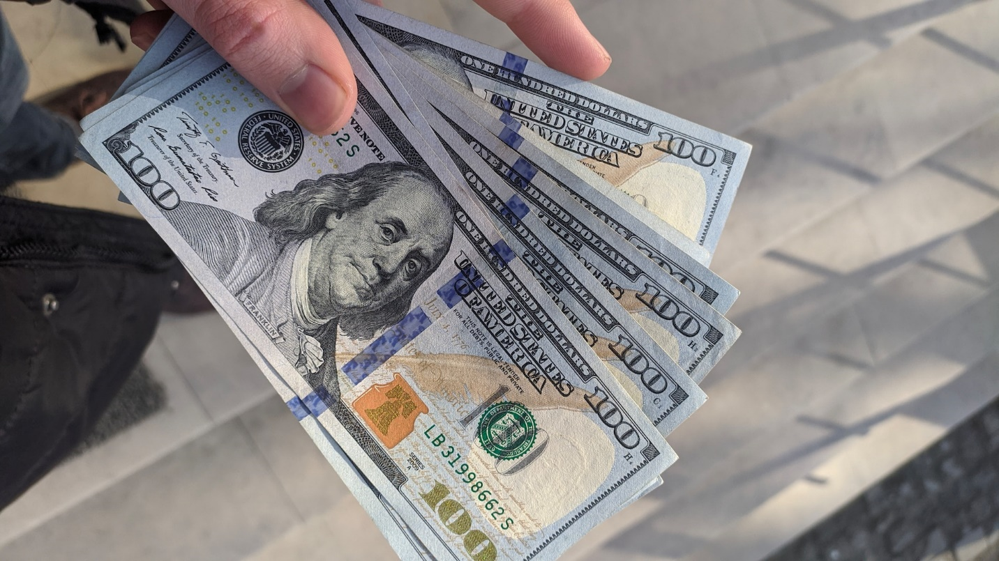Photo by Frederick Warren on Unsplash
The U.S. Department of Labor released new data today showing a 0.6% increase in the consumer price index (CPI) for August. This is the largest monthly rise in U.S. inflation so far this year. The report showed that prices have gone up by 3.7% compared to August of last year, slightly higher than what economic analysts had predicted.
The CPI is used to measure the average change over time in the cost of goods and services.
Economic analysts, who were polled by Dow Jones, had predicted the increases to be 0.6% and 3.6% respectively.

Energy Costs Contribute Significantly to US Inflation
When food and energy prices are set aside, the core CPI saw an uptick of 0.3% for the month and 4.3% year-over-year. This core index is given more attention by Federal Reserve officials because it offers a clearer picture of long-term inflation trends. During August, energy prices saw a rise of 5.6%, which included a substantial 10.6% jump in gasoline prices.
Food prices went up by 0.2%, while the costs related to housing, which accounts for roughly a third of the CPI’s weight, rose by 0.3%. The rent for primary residences increased by 0.5% and showed a 7.8% hike compared to last year. The owners equivalent rent, a metric that assesses what homeowners think they could charge for rent, rose by 0.4% for the month and 7.3% for the year.
The report also revealed that airfares increased by 4.9%, although they are still 13.3% lower than they were a year ago. Prices of used vehicles, which played an important role in boosting the inflation rate in 2021 and 2022, dropped by 1.2% and are now 6.6% lower year-over-year. Transportation services experienced a 2% increase in August.

Housing’s Role in Inflation Rate
According to Lisa Sturtevant, the chief economist at Bright MLS, if housing costs were excluded from the CPI, the annual inflation rate would only be around 1%.
“Housing continues to contribute an outsized share to the inflation measures,” Sturtevant said to CNBC. “Rent growth has slowed considerably and median rents nationally fell year-over-year in August. … However, it takes months for those aggregate rent trends to show up in the CPI measures, which the Fed must take into account when it takes its ‘data driven’ approach to deciding on interest rate policy at their meeting … later this month.”
After the release of the inflation report, stock market futures initially dipped but later recovered. Treasury yields also saw an upward movement. Meanwhile, the rise in US inflation affected workers’ earnings. Real average hourly earnings dropped by 0.5% in August, even though they are still 0.5% higher than last year.

Federal Reserve’s Approach to Tackling Inflation
Recent remarks suggest that Federal Reserve officials are in the process of developing a long-term strategy to address the issue of inflation. Since March 2022, the central bank has increased its benchmark borrowing rate by 5.25 percentage points to control inflation, which reached a peak not seen in over four decades last summer.
Recent statements from officials suggest a more balanced view on the risks and a greater caution concerning future rate increases.
“Overall, there is nothing here to change the Fed’s plans to hold interest rates unchanged at next week’s [Federal Open Market Committee] meeting,” wrote Andrew Hunter, deputy chief U.S. economist at Capital Economics.
Market predictions for future Federal Reserve actions are fluctuating, with traders estimating about a 40% chance for another rate hike in November, based on data from CME Group.
The latest data provides a comprehensive snapshot of where the economy stands with regard to inflation. While market reactions have been mixed, the figures underline significant shifts in various sectors, from energy to housing.
Federal Reserve officials and market analysts will undoubtedly keep a close eye on these developments as they consider future policy actions. The fluctuations in sectors like housing and transportation services bring additional layers to the inflation discussion, making the coming months crucial for understanding long-term economic trends.

Record $307 Trillion Global Debt Puts World Economy on Alert
Image by PublicDomainPictures from Pixabay
In the first half of 2023, global debt increased by $10 trillion, reigniting concerns about its impact on the world economy and the potential for a financial crisis, according to data released by the Institute of International Finance (IIF) on Tuesday.
The report disclosed that the overall debt has climbed to an unprecedented $307 trillion, marking a $100 trillion rise over the past decade.

Dominance of Mature Markets in the Global Debt Increase
Countries like the United States, the United Kingdom, Japan, and France were mainly responsible for the rise in debt during the first half of the year, contributing to over 80% of the increase.
On the other hand, developing countries such as China, India, and Brazil recorded the biggest upticks in debt within emerging markets.
The IIF expressed concern over the high levels of domestic government debt in many developing countries, stating that the current global financial systems are not well-equipped to handle this situation.
The report suggested that a market-based approach could help in managing unsustainable levels of domestic debt and could assist in allocating resources for developmental and climate finance.

US Economy and Financial Crisis Concerns Amid Rising Debt
The IIF report also highlighted that the global debt-to-GDP ratio rose from 334% at the end of last year to 336% and is expected to reach 337% by the end of 2023. These increases are primarily due to large government budget deficits. This level is still below the peak of 362% reached in the first quarter of 2021, however.
Emre Tiftik, the IIF Director, attributed the brief decline in the global debt ratio over the past two years to a sudden increase in inflation, which allowed many countries and corporations to reduce their debt relative to their local currencies.
In a somewhat positive development, the report noted that household debt in mature markets has decreased to its lowest level in two decades during the first half of 2023. The report suggests that if inflation continues in these markets, the stable financial condition of households, especially in the United States, could serve as a buffer against future interest rate increases.

Federal Reserve’s Interest Rate Strategy
The Federal Reserve, which has increased interest rates by over five percentage points in the past 18 months, opted not to hike rates in its September meeting, but hinted at another possible rate increase before the year’s end.
Alexandra Wilson-Elizondo, deputy chief investment officer of multi-asset strategies at Goldman Sachs Asset Management, stated that the Federal Reserve’s latest stance was more cautious than anticipated. She noted that the main challenge for the central bank is to maintain its credibility in fighting inflation.
In addition, Wilson-Elizondo mentioned that recent increases in energy prices and positive economic indicators likely influenced the Federal Reserve’s projections.
She indicated that although there is no single factor that could drastically affect the market, a combination of events like labor strikes, government shutdowns, and the resumption of student loan payments could introduce some volatility in the economic data.
In short, the world economy is facing growing uncertainties with global debt hitting record levels. While mature markets like the US, the UK, Japan, and France continue to be the major contributors to this debt, developing economies are also experiencing increases that are causing concern among financial experts.
The situation warrants close monitoring to understand its long-term implications on both global and domestic scales.

Dogecoin Price Prediction as Doge Pumps 30% After Twitter Logo Rebrand – Is Love Hate Inu Next to Explode?
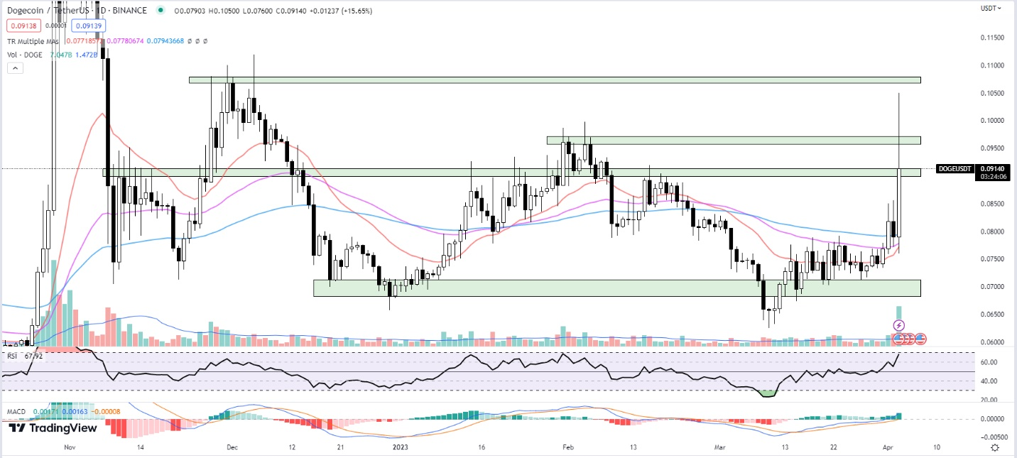
Dogecoin’s value skyrocketed by over 30% today after Elon Musk’s Twitter adopted the meme coin’s symbol as its logo. The change took place following his recent request to dismiss the $258 billion Dogecoin lawsuit he’s facing.
After reaching a peak price of $0.1016, Dogecoin has retraced by 8.8% and is now trading at $0.091.
Is the recent surge in Dogecoin’s price a sign of things to come for other meme coins? Or is it merely a reflection of the pump power that a single tweet from Elon Musk can wield?

The Doge Days of Twitter: A New Icon, a New Era
The connection between Dogecoin’s recent price surge and the social media juggernaut’s logo change is undeniable. Twitter’s decision to (at least temporarily) replace its iconic bird with the equally iconic Shiba Inu face of Dogecoin has brought the cryptocurrency into the spotlight for the platform’s 360 million monthly active users.
The development, coupled with Musk’s Twitter post featuring a meme alluding to the permanence of the rebrand, has generated a lot of buzz on Twitter, with many speculating the move is not permanent and merely a late April fool’s joke.

Musk Twitter and the Dogecoin Phenomenon
Throughout the years, Elon Musk has shown a penchant for influencing the prices of various cryptocurrencies, with Dogecoin being one of his favorite targets. Musk’s Twitter activity has repeatedly demonstrated its ability to affect the value of the meme coin.
From his self-proclaimed title of “Dogefather” to his endorsement of Dogecoin as “the people’s crypto,” the CEO’s tweets have undeniably played a significant role in the coin’s market fluctuations.
In September 2022, Tesla, Musk’s electric car company, released a series of Cybertruck-inspired whistles with a price tag of 1,000 DOGE (or $60 at the time). This unconventional pricing strategy further solidified the connection between Musk and Dogecoin.
Musk’s collaboration with Dogecoin developers also led to a 25% reduction in the coin’s carbon emissions, proving that the entrepreneur’s involvement in the project extends beyond mere tweets.
However, Musk’s Twitter presence has also sparked concerns about potential market manipulation. The billionaire’s history of impulsive tweets has already cost him a $20 million fine from the U.S. Securities and Exchange Commission in 2018, following misleading statements about Tesla’s stock.
As Musk continues to wield his influence over the cryptocurrency market, questions about the ethics of his actions become increasingly relevant.

A Legal Minefield: Musk and the $258 Billion Lawsuit
On June 2022, Musk’s antics landed him in hot water once more, as a Dogecoin investor filed a $258 billion lawsuit against him, Tesla, and SpaceX. The plaintiff, Keith Johnson, alleged that Musk’s promotion of Dogecoin on Twitter was part of a pyramid scheme designed to inflate the coin’s value before letting it crash.
Musk’s legal team has countered these claims, arguing that sharing humorous images and expressing support for a cryptocurrency on Twitter cannot constitute fraud.
Last week Musk requested a U.S. judge to dismiss the lawsuit.
As the impact of celebrity endorsements and market speculation continues to prop up meme coins, the potential for other meme coins like Love Hate Inu to experience a similar price surge is high. More on this below.
But first, let’s examine Dogecoin’s technical indicators to better understand its possible future price trends. The following analysis sheds light on the technical aspects that may influence Dogecoin’s market trajectory in the coming days.

Dogecoin on the Cusp of a Bullish Breakout? Technical Indicators Point to Growing Momentum
Dogecoin (DOGE) is experiencing significant price movement at the moment, having reached an intra-day high of $0.10500. The price has slightly stabilized as of writing, but is this a sign of a bullish reversal for the most famous meme coin, or is it just a failed breakout?

EMA Crossover
Dogecoin’s 20-day EMA is currently at $0.07713, while the 50-day EMA stands at $0.07776, and the 100-day EMA is at $0.07941. The convergence of these EMAs suggests that Dogecoin’s price trend is stabilizing, and a bullish crossover could be in the works.

RSI and MACD Indicators
The RSI is a momentum oscillator that measures the speed and change of price movements. Currently, Dogecoin’s RSI is at 67.15, which is a significant increase from the previous day’s RSI of 55.15. This indicates that buying pressure has increased, and the market sentiment is still bullish.
The MACD histogram for Dogecoin has increased from 0.00096 to 0.00163, further supporting the growing bullish sentiment.

Resistance and Support Levels
At the time of writing, Dogecoin is trading at $0.09140, representing a 15.65% increase so far today.
Dogecoin is currently facing immediate resistance at the $0.10666 to $0.10794 range. If the price convincingly clears this level, the next resistance area to watch is between $0.13562 and $0.13812.
On the other hand, if a failed breakout occurs, immediate potential support can be found at $0.09571 to $0.09718, followed by a more significant support area at $0.08980.
The technical indicators for Dogecoin suggest that a bullish reversal might be in sight. However, because the coin’s price surge was a result of Twitter’s marketing ploy, it is uncertain how the near term price momentum of Dogecoin will play out.

Love Hate Inu: Dogecoin Alternative with More Potential Upside
For a less risky meme coin that might benefit from the recent move as Dogecoin loses momentum, traders can look to Love Hate Inu, which could have more potential upside in the current meme coin rally.
The upcoming vote-to-earn (V2E) memecoin initiative, Love Hate Inu, has raised $2.67 million from investors just weeks after its presale launch. The project aims to transform the conventional survey sector by introducing a utility-focused V2E mechanism and cutting-edge blockchain technology, which could yield substantial returns for early $LHINU token adopters.
Typically, meme cryptocurrencies rely on media hype and enthusiastic communities for their success. However, this often results in a decline when the hype subsides, as most meme projects lack substantial use cases for global industries.
Love Hate Inu aims to break this mold, becoming the first meme coin to offer both versatile utility and viral popularity. With a lighthearted and meme-inspired design, Love Hate Inu plans to enter the $3.2 billion survey industry to solve some of its challenges, including censorship and lack of rewards.
Deployed on the Ethereum blockchain, this meme crypto enables members to vote on a wide range of polls and surveys, including contentious and debatable issues. All votes are recorded on the blockchain, guaranteeing transparent, authentic, and tamper-proof results, while rewarding users and giving brands the data they need to move their products forward.
As for Dogecoin, traders should keep an eye on the mentioned resistance and support levels to gauge the market sentiment and make informed decisions. As always, exercise caution and employ risk management strategies while trading in volatile markets.

