Cere Vision Article Blog
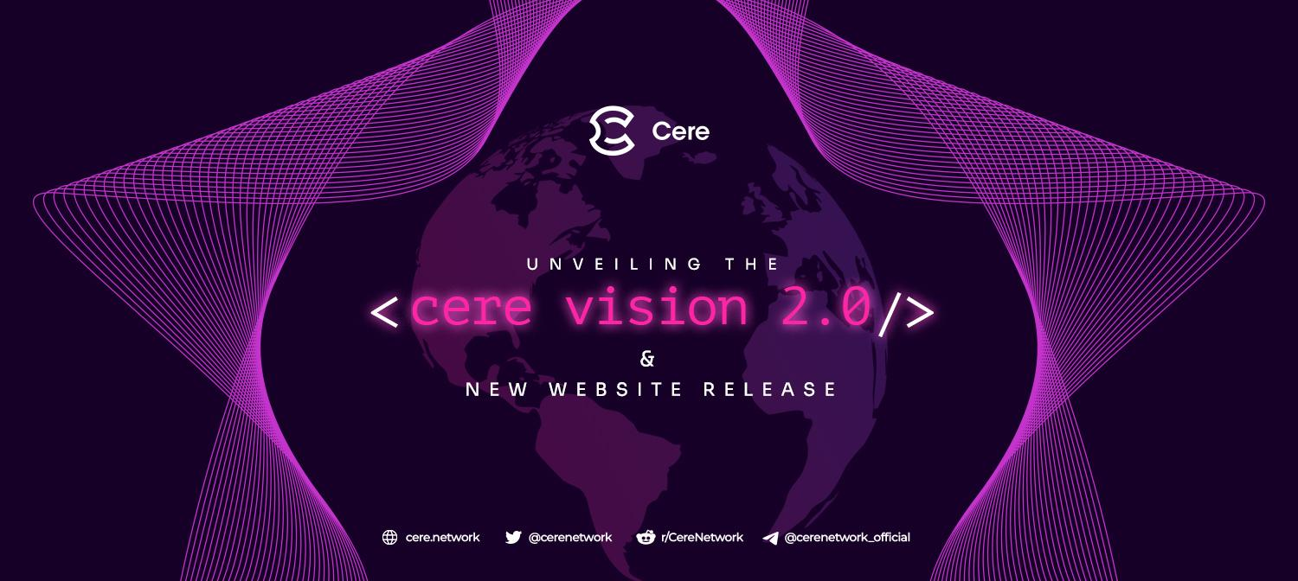
In a world where power, money, and information are increasingly concentrated, decentralization is paramount. We can no longer give piecemeal support to Web3 ideals. We must act swiftly so that everyone can access truly decentralized and participatory solutions.

The second article in the “Vision 2.0” series has landed, and we’re happy to bring Cere supporters into the loop on our exciting updates for our evolving mission to make Web3 truly decentralized. We are more clear in our mission than ever to untether content creators, production companies, application developers and users, viewers, and gamers from big tech and middlemen.

The internet’s “big five” (Amazon, Apple, Alphabet/Google, Meta, and Microsoft) own more than 80% of all corporate data worldwide. All this data is hoarded within their own data centers where they use it to manipulate consumers and make money from advertisers and partners.
Application owners, developers, and content creators (artists, musicians, studios, and others) are tied to these limited-interoperability data silos when building new products or services. The lack of alternatives gives the big tech companies immense power over the media and content we consume.
Cere aims to give this power back to users and content creators. The Vision 2.0 article demonstrates how Cere’s Decentralized Data Cloud (DDC) and Tools & Services can achieve this.
The Vision 2.0 article will soon be followed by the launch of our new website, which will showcase some of the exciting use cases and partnerships we have in the pipeline. The development of our platform, protocol, services, and tools is advancing quickly and many tools and services are ready to use!

Introducing DaaS (Decentralized) Data-as-a-Service
Bringing DaaS to existing companies that already have large audiences and user bases is key to the mass adoption of decentralized utility, and soon we’ll be able to demonstrate the true power of our ecosystem with just such partners.
These use cases will highlight the power of our Decentralized Data Cloud (DDC) and the Cere Tools & Services Suite that it powers.
- The Cere DDC: The world’s first blockchain solution for handling large quantities of live data securely, designed for NFTs, connected data, and media.
- The Cere Decentralized Content Delivery Network (dCDN): The dCDN is an improvement on centralized CDN services like AWS and Cloudflare and can be used to directly stream media and game assets in a decentralized way to users who own the content rights, reducing costs and overhead.
- Cere Freeport: Our NFT minting platform that empowers content creators and distributors with a prepackaged set of open-source smart contracts and services to maximize the impact of their content campaigns. Freeport makes it easy to mint and list NFTs in fixed price sales or auctions, manage multiparty NFT royalties, and store NFT assets securely and encrypted.
- Cere Universal Wallet: Can be used by any application to allow users to directly access their content on the DDC.
- CereContent Management System (CMS) and NFT Marketplace: Allows content creators and production companies to easily set up white-label marketplaces to connect with and provide experiences to their fans and users. Any game developer, brand, studio, label, artist, musician, filmmaker, or other creator can self-publish content that can be directly attached to NFTs minted, marketed, and directly streamed to the purchaser of the NFT.
- Cere Decentralized Data Viewer (DDV): Allows users to connect their wallets and scan the Cere DDN for the data they own.
- Other Tools and Services: The decentralized, universal NFT/content registry, The Cere Real Time Experience Builder (RXB), improved SDK, and others.
Centralized data creates many issues for users and media companies, including for privacy, security, reliability, and censorship. Cere Network will fix these issues while simultaneously creating undreamed-of use cases for the new media landscape.

Use Cases
Use cases that are already live include a gaming demo that GameFi and NFT-based games can try now, as well as the DaVinci NFT Experience platform currently demonstrating a new way to buy and sell NFTs while cutting out big tech and middlemen.

Cere’s white-label NFT marketplaces are also ready to be used by content producers, and partners using the platform for media projects will be announced soon.

For more information about our use cases and to learn more about how to monetize and distribute your own content with the power of Web3 or integrate DaaS and/or NFT experiences into your dApp, game, or media outreach efforts, get in touch with the Cere team.
To learn more about our vision for bringing true decentralization to Web3, check out our Vision 2.0 article here!

