How to Get the Most out of Acumatica Distribution Edition
Modern distribution ERP software is critical for distribution companies to remain competitive in an age of digital transformation. The best ERP for distribution depends on your company’s unique needs, but Acumatica’s distribution ERP is a robust solution we recommend to our clients because of its complete array of automation and visibility features, user-friendly interface, and ability to integrate with multiple wholesale distribution ERP

Acumatica Distribution Management Software: Specialized ERP Software for Distribution
Acumatica Distribution Edition is a cloud ERP system for distribution companies. Whether you already have your Acumatica distribution ERP systems set up and are looking to optimize them or are thinking of implementing a distribution ERP system, this article will help you get a sense of how to make the most out of this powerful solution.

Acumatica’s Distribution ERP Software Features and Applications
A distribution ERP should contain key distribution ERP software features needed by your organization, depending on your company’s needs. The below application modules can integrate Acumatica’s distribution ERP with other business modules for a fully rounded wholesale distribution ERP software that synchronizes data and functions across all departments.

Acumatica Distribution Edition application modules include:

Inventory Management: Basic real-time inventory functions needed for any ERP system for distribution.

Sales Order Management: A key function of any ERP, distribution industries are particularly reliant on these functions for order entry and fulfillment.
Purchase Order Management: A main distribution ERP module to manage global purchasing processes.
Requisition Management: Another key module for a wholesale distribution ERP. Wholesale distribution companies often have complex webs of suppliers and products. This module automates and simplifies key requisition processes.
Warehouse Management System (WMS): A vital application of any ERP for distribution, this module contains functions for inventory management, receiving, and order fulfillment.
Order Management: Companies that will benefit from ERP wholesale distribution software that can automate and streamline procurement and order fulfillment will benefit from this module.
Advanced Financials: Although not needed for all ERPs, for wholesale distribution companies with more advanced financial tracking and accounting needs, this module can augment basic financial functions.
Service Management: A key function of an ERP for distribution companies that take care of customer issues in the field, such as repairs of equipment.

Equipment Management: Any industrial distribution ERP for companies dealing with equipment sales and service should integrate this module.

Simplify Acumatica Distribution Views and Processes
Many built-in functions of Acumatica’s ERP for distribution allow you to streamline the interface for different users, roles, and preferences:
- Declutter Views: Configure the Dashboard and columns within different applications and views or add functions as needed for different roles.
- Wizards: Many processes are simplified by step-by-step wizards.
- Pallets and Boxes: Set the number of items in boxes and pallets for quick-scanning multiple items into inventory.
- Favorites: Create a streamlined view of most-used tools and views.
- Colum Configuration: Remove data columns you don’t need.
- Filtering: Show only the data you need. E.g., under Sales Orders, view only Open orders; Use chart view functions to easily show specific sales team member performance and other data.
- Customize Menu Items: Pin most-used workspaces to the menu.

Mobile Distribution ERP Apps
A cloud ERP for distribution companies must have robust mobile functionality, and Acumatica delivers. Set up the Android or iOS app to take care of tasks on-the-fly, including:
- Approvals: Easily review details and approve or reject Purchase Orders, Projects, etc.
- Expense Receipts: Snap receipts to add and review expenses directly from your mobile device.
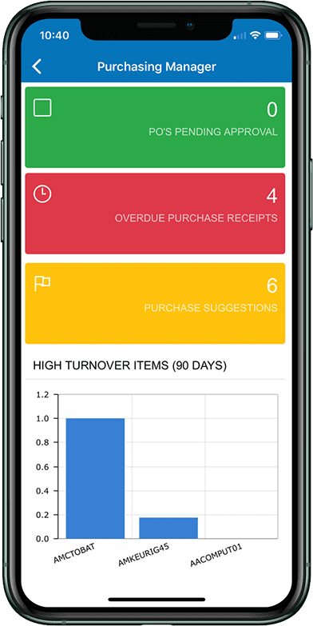
Quickly Navigate Data and Views
- Dashboards: Customize the dashboard to view and take action on critical information.
- Universal Search: Search from anywhere for anything, including for menu items, prospects, leads, cases, help topics, files, etc.
- Recently viewed items: View recently viewed records to quickly access recent work sessions.
- Set Date: Set your date back to quickly process items from that date.
- Activities: Assign tasks and gain visibility into projects, linking tasks to relevant files and notes.

Automate Your ERP for Wholesale Distribution
Modern ERP distribution software should save time. Acumatica’s ERP wholesale distribution solution has many automation features that do just that:
- Automate Purchase Orders: Automatic purchase suggestions based on inventory levels and automatically send emails to responsible team member(s).
- Carrier Shipping Integration: Automatically get shipping quotes from integrated shipping accounts and select the best one.
- Automate Payment Processes: Set up payment details and let the system take care of all payments based on your preferences.
- Shared Data: Share data across departments and locations with an integrated rules-based workflow. Split orders between warehouses, allocate inventory, and easily issue replenishments.
- Streamline Set Up: Assign user rights in bulk to create user roles quickly.

The Future of Distribution ERPs is Now
The future of distribution ERPs is extensible, multi-featured, user-friendly, and automated. If you’re overwhelmed by the shear number of features available in Acumatica: Distribution Edition or other ERP distribution software you’re considering, don’t hesitate to get support from a distribution ERP provider such as Kissinger Associates to set up these applications and features for your ERP. Distribution industries of the future will look back on this as the beginning of the ERP revolution that finally made complex supply chain management simple for distributors.
To get help setting up and making the most out of Acumatica’s distribution ERP, get in touch with Kissinger Associates to schedule a demo today.

