Trent Rhode
University of Victoria
Student #V00043053
November 20, 2021

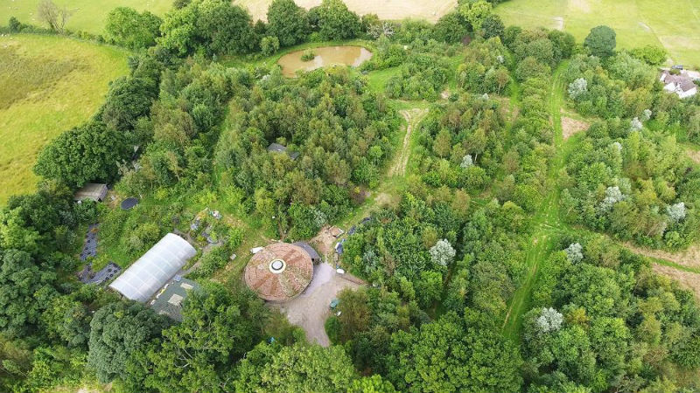

Mitigation and Remediation of Compacted Farmland Soils Using Multifunctional Woody Polyculture Systems – A Review

Cover image: “Forest garden.jpg,” Permawiki.¹

Table of Contents

Table of Contents 2
Introduction 2
Causes, Effects, and Quantification of Soil Compaction 3
Causes and Effects 3
Soil Compaction Quantification 5
Soil Compaction Control and Remediation Using Multifunctional Woody Polycultures 6
Basic Strategies 7
Multifunctional Woody Polyculture Systems 8
Conclusion 14
References 15

Introduction
Soil compaction is a growing and widespread problem in agriculture throughout the world^{2–6} and its causes and effects have long been known⁷. It can be defined as a bringing of soil particles closer together, resulting in an increase in bulk density of the soil and a decrease in soil porosity, usually due to vibration, tillage, or applied loads^{8–12}.
This reduces water infiltration, aeration, root growth, and hydraulic conductivity^{9–14}. These effects can increase surface runoff, soil erosion, and denitrification, harm soil ecosystems, and reduce plant health and growth^{3,14–19}.
The literature on the negative impacts of tillage, lack of vegetation, and heavy machinery on soil compaction and general soil quality is already vast and incontrovertible^{2–36, 39, 44, 58–64, 69–71}. This literature review therefore focuses on soil compaction prevention and remediation strategies. It gives particular attention to the potential effectiveness of continuous vegetation cover from Multifunctional Woody Polycultures (MWPs) in preventing and remediating soil compaction.

Causes, Effects, and Quantification of Soil Compaction

Causes and Effects
Before examining how to repair soil compaction, it is first important to understand its causes and effects. Compacted surface and subsurface layers, often called pans, exist in many agricultural soils, both due to the soil structure-destroying effects of tillage as well as the compressive impact of heavy farm equipment and livestock^{8–12,20,21}. Rain can cause surface compaction as well – also known as crusting – on soils lacking vegetation or mulch^{22,23}.
Wet soils and soils high in clay and low in organic matter are especially suspectable to compaction, and the heavier and more frequent compressive forcers are, the deeper compaction penetrates and the harder it is to rectify. Further, once tillage has disturbed soil structure, the soil becomes more susceptible to recompaction than soil that has not been tilled²⁴.

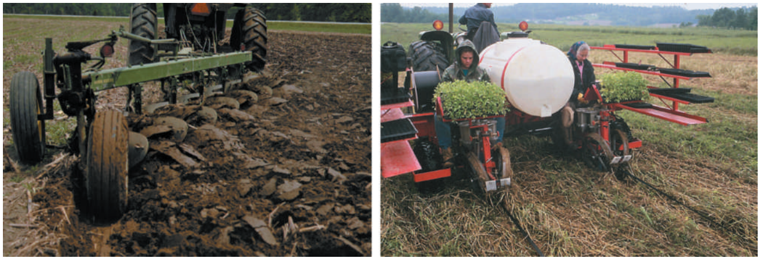
Figure 1 - Left: A plow inverts soil while burying residues and creating bare soil. Right: Tomato seedlings are planted directly into mulch from a cover crop with no soil inversion and little disturbance, greatly reducing soil compaction potential²⁵.

One of the primary characteristics of compacted soil is increased bulk density. Bulk density refers to the ratio of pores to solid material in a unit of soil and is a key indicator of soil compaction¹⁴. Compression creates a downward force that destroys soil structure, decreasing porosity by reducing the number, size, and continuity of pores, which negatively affects the distribution of both air and water¹³. Tillage also destroys soil structure, likewise creating an increase in bulk density and a decrease in soil porosity^{3,10–13,26}.
This, in turn, leads to poor soil aeration, impairing the function of plant roots^{6,27} and the microbiome¹⁶ and causing a buildup of toxic gases and root exudates, which is not conducive to plant health²⁵. This lack of soil structure and pore space for water also coincides with decreased infiltration, permeability, hydraulic conductivity, and poor water uptake by plants, as water cannot as easily penetrate and move through compacted soils.¹⁸ As a result of decreased water infiltration, there is also increased runoff, and thus erosion^{3,23}. These water-related issues can also lead to desertification in certain climates²⁰.
Low oxygen and water volumes in the soil or waterlogging in compacted fine-textured soils can then lead to poor conditions for soil microorganisms and other soil life important for plant health¹⁶. The potential anaerobic conditions can also increase soil denitrification processes. This, in turn, can lead to poor plant nitrogen availability²⁸, increased fertilizer use, and higher costs for farmers⁵.
Roots also have difficulty penetrating compacted soil and their growth is further restricted by a hormonal response to an accumulation of ethylene caused by decreased gas diffusion in low-porosity soils²⁹.
Root growth, along with general plant health and growth is negatively impacted by all the above factors. Recovery depends on whether compaction affects the topsoil or subsoil. As Stoessel et al. note in their 2018 assessment of the environmental impacts of soil compaction, “compaction in topsoil is classified as reversible in the short term (approximately four years), while recovery of subsoil layers takes much longer”²⁴.

Soil Compaction Quantification
Before endeavouring to repair soil compaction one should first discover the degree of compaction using any of several available assessment techniques. These include visual and tactile inspection in the field, examination of root systems, predictive computer modelling, bulk density measurement, soil strength, cone penetration resistance with penetrometers, and use of sensors³.
As noted in a 2009 soil compaction and management review by Batey, however, data obtained from some field measurements may be misleading³. For example, soils with a coarse prismatic structure may still have sufficient pathways for roots and water via shrinkage fissures even though they have high penetration resistance. Such measurements must therefore coincide with an examination of the soil profile to get a true picture of soil compaction effects on plant growth. Criteria used in the field to assess compaction include waterlogging, soil strength, visible porosity, soil structure changes, colour of soil, soil moisture, and root distribution. As noted by Batey (2009), comparing potentially compacted soil with nearby uncompacted soil, such as soil beside a fence or within a treeline, provides a local baseline for identifying changes caused by compaction³.

Soil Compaction Control and Remediation Using Multifunctional Woody Polycultures
Before exploring how MWPs can prevent and remediate compaction, it is necessary to review the main prevention and remediation strategies.

Basic Strategies
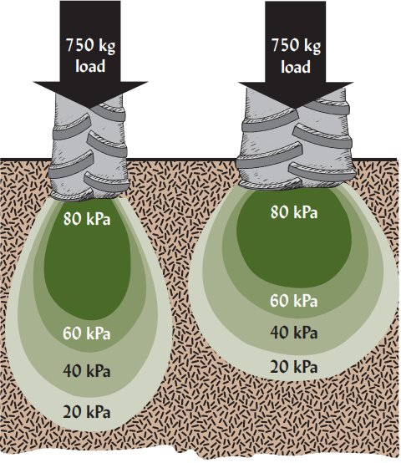
Figure 2 – The narrower the tire, the more it sinks and the deeper the compaction.²⁵
Common and well-substantiated soil compaction prevention and remediation strategies include:
- Use twin-tires and wide-tire machinery with reduced tire pressure if machinery use cannot be avoided²⁶.
- If plowing, plow out of the existing furrows to avoid subsoil plow pans³⁰.
- Use conservation tillage practices: this includes no-till, as no till soils are more resilient to compression by heavy machinery and this avoids destruction of soil structure and thus increased bulk density and decreased porosity³¹. At the very least, minimal tillage should be done, especially avoiding tilling when the soil is wet and avoiding multiple passes of machinery²⁴.
- Preserve crop residues and use mulch: as Gabriel et al. (2021) note, even bare soil becomes resistant to compaction with reduced tillage, but crop residues left on the soil surface help reduce compaction even more³². Other forms of mulch such as straw also help mitigate compaction³³.
- Add organic matter: enriching the soil with organic matter will improve structure, make the soil more resistant to compaction, and repair existing compaction. It does this by making soil aggregates more stable and creating soil properties similar to a sponge that help the soil bounce back from compression^{26,34}.
- Cover crops and vegetation cover: ensuring that the soil is continuously covered with vegetation, such as by using cover crops, and especially tap-rooted plants, both prevents compaction and breaks up existing compaction layers^{23,27,32,35–37}.
- Subsoil ripping: Prior to implementing no till or reduced tillage systems, subsoil plowing with a chisel plow or other type of subsoiler can help to loosen existing compaction layers³⁸. Subsoiling typically brakes up compaction layers at between 30 to 40 centimeters, increasing aeration and water infiltration. However, effects may be temporary if machinery traffic continues as normal afterwards²⁷. Additionally, the soil should be covered afterwards with mulch or cover crops to avoid erosion²⁵.
- Control traffic: avoid traffic during wet soil conditions and use only permanent lanes for traffic to minimize compressive forces on the soil³⁹.
The literature on the above mitigation and remediation strategies is broad. This review next examines how permanent vegetation cover in MWP systems can combine several of these strategies to prevent and repair soil compaction.

Multifunctional Woody Polyculture Systems
Multifunctional Woody Polyculture systems herein refer to plantings of two or more species, at least one of which is a woody perennial. These species are selected to maximize beneficial ecological and productivity effects, minimize competition, and usually support ease of harvesting.⁴⁰
MWPs are interesting because they can accommodate all the above soil compaction mitigation and remediation strategies while remaining productive. Specifically, MWPs lend themselves to no-till permanent cropping with permanent paths and roads^{31,39}. They can integrate tap-rooted plants^{27,35–37,42–46}, produce their own mulch⁵⁶, include ground covers^{42–46}, maintain permanent, diverse vegetation on the soil and prevent bare soil²³, reduce the need for vehicle traffic^{31,39}, and build organic matter and optimal soil structure³⁴. Further, economically viable crops such as a variety of nuts, fruit, and grains can be utilized^{40,41,52}.
Lovell et al. (2018) describe MWPs as multispecies systems arranged in layers that resemble natural woody plant communities. By occupying different canopy and rooting niches, these systems can use light, nutrients, and water efficiently while maintaining productivity and other ecosystem services⁴¹.
Importantly, as mentioned, MWPs lend themselves to no-till farming and permanent roads and paths, since the crops themselves are relatively permanent and can easily be designed around as long-term landscape features. Rather than tilling for weed control, weeds are suppressed naturally by cover crops such as clover, alfalfa, and other legumes, perennial grasses, or other perennial groundcovers, while soil structure is simultaneously improved and compaction reversed, especially when tap-rooted species are incorporated^{27,35–37,42–46}.
Avoiding tillage and widespread machinery traffic not only has beneficial effects on limiting soil compaction, but it also opens up the possibility of keeping continuous vegetation coverage on the soil in the form of woody and non-woody perennials, including the aforementioned cover crops, as well as additional production crops with tap roots such as walnuts^{47,48}, pecans⁴⁹, hickories⁵⁰, persimmons⁵¹, and many others⁵². Perennials typically allocate more resources to deeper root growth than annuals^{53,54}, theoretically allowing them to break up deeper compaction layers. Keeping vegetation permanently covering soil also prevents bare soil. Bare soil is vulnerable to erosion, which can reduce soil organic matter and transport nutrients and soil biota²³. In other words, bare soil encourages compaction.
In perennial no-till systems heavy machinery use can also be reduced, since ploughing is not needed and fertilizer and pesticide applications may also be reduced, while harvesting equipment such as combines or straddle harvesters can be relegated to alleys between woody perennials or to established pathways.
Another key compaction prevention strategy is to grow a variety of different plants in a cropping system (i.e. polycultures) instead of relying on single species monocultures. Although little data exists on woody polycultures and soil compaction, it has been shown that diverse crop rotations involving annuals lead to less soil compaction than monoculture systems⁵⁵.
MWPs can also include fast-growing woody or herbaceous plants that are cut and left on the soil surface as mulch, as in Inga alley cropping⁵⁶. This is a key consideration in MWP design because mulch can reduce soil compaction³³ and contribute organic matter to the soil³⁵.
Although there has been little research comparing perennial agriculture to annual agriculture in general, there are some studies that can illuminate the question of whether perennial vegetation is more effective than annual vegetation at preventing and remediating compaction. We can also examine available literature on soil quality factors related to compaction in cultivated agricultural soils and compare them to forest and other natural ecosystem soils to glean additional insights.
One such 2018 study by Bhavya et al. found that, compared to tillage based annual vegetable and herb plots, mango and cashew orchards in the same vicinity with the same soil type had significantly lower bulk density, and much higher organic matter and porosity. The authors noted that this was due to the ongoing contributions of organic matter by permanent perennial crops, which has beneficial effects on soil aggregates and reduces soil bulk density. Meanwhile, as they note, annual-based cropping systems that involve tillage cause the breakdown of soil aggregates, increasing the bulk density of the soil⁵⁸.
Other studies have also shown the benefits of perennial and perennial woody plants compared to annual cropping systems on soil structure (including aggregate size and stability), organic matter content, porosity, and bulk density – all key measures of the level of compaction of a soil²⁵:
- A 2007 study comparing forest soil to nearby cultivated land in Pakistan showed significant structural deterioration of the cultivated land, with a 13% higher bulk density and a 12% lower porosity⁵⁹.
- A 2015 study comparing perennial vegetation to an annual tillage system in Brazil found that conventional tillage significantly reduced aggregate stability and soil organic matter content compared to both an adjacent forest and a coffee tree plantation⁶⁰.
- A 2000 study comparing porosity, bulk density, and organic matter of conventional annual agricultural land, native forest, palm oil/cocoyam plantations, and grassland in a region of Nigeria found that the agricultural land had significant structural degradation. Porosity, bulk density, and organic matter indicators were similar in forests and grasslands, and significantly better in palm oil/cocoyam plantations compared to the agricultural land.
- A 2002 study in the Midwestern United States showed that water infiltration was five times higher under multi-species woody plantings buffering riparian zones compared to adjacent pasture and cultivated fields. Bulk densities under multi-species buffers were also significantly lower⁶¹.
- A 2005 study in Turkey showed similar destruction of soil aggregates, a decrease of organic matter by 49%, and an increase in bulk density of tillage-based agricultural soils compared to adjacent forest and perennial pasture lands⁶².
- Further studies in Iran in 2008 and 2018 confirm the above benefits of perennial vegetation cover on soil compaction attributes^{63,64}.
The question of whether human-designed perennial polycultures can have similar beneficial impacts compared to natural vegetation cover on soil compaction has also been asked:
Study and location | Comparison | Compaction-related finding
Chowdhury et al., Bangladesh (2019) | Agroforestry plots compared with reforestation plots | Soil organic matter was higher in the agroforestry plots, but bulk density was also higher because of heavy machinery use⁶⁵.
Berish and Ewel, Costa Rica (1988) | Human-designed woody polycultures compared with native forests | Fine-root mass was comparable to that of native forests, implying similar organic matter contributions; roots also help prevent and remediate compaction⁶⁶.
Udawatta et al., Midwestern United States (2008) | Agroforestry strips compared with an adjacent annual corn-and-soy rotation | Pore connectivity was three to five times greater, and aggregate stability was also significantly greater in the agroforestry strips^{67,68}.
Basche and DeLonge (2019) | No-till, crop rotation, livestock systems, cover crops, and perennial systems | Grass, agroforestry, and managed forest systems with perennial plants had the highest infiltration rates, implying significantly less compaction⁶⁹.
Ohio bioenergy crop study (2021) | Perennial biofuel crops compared with annual bioenergy crops | Perennial crops improved aggregate stability, reduced bulk density, and had 41% higher organic matter⁷⁰.
German bioenergy crop study | Perennial crops compared with annual crops | Perennial crops had 65% higher aggregate stability⁷¹.
The evidence reviewed in the above table indicates that MWPs can promote soil health and prevent or remediate compaction. The next question is whether these systems are as productive as annual cropping systems. If they are not, there is little incentive for farmers to implement them. Although there have been few studies demonstrating yield comparisons between conventional annual cropping systems and MWPs, what little research is available is encouraging.
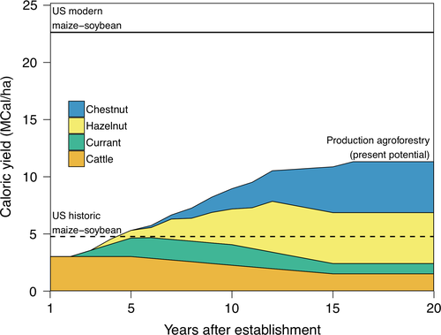
One such example is an experimental agroforestry site in Montepellier, France, which has demonstrated that its 100 ha MWP alley cropping system can produce as much as a conventional farm of between 130 to 160 ha⁴¹. A predictive model by Lovell et al. (2018), based on available data, also indicates that a perennial polyculture may produce higher yields than a conventional corn- and soy-based annual system^{41,72}.
Figure 3 - A theoretical model developed by Lovell et al. is useful for exploring the question of MWP productivity and understanding potential changing yields over time^{41,72}.

Much more research on demonstration sites across the planet is needed to compare the yields of conventional annual systems and MWPs and to better quantify their ecological benefits, including their benefits related to soil compaction – as well as to demonstrate how to design and implement them in a variety of climates and contexts. Indeed, surveys and studies have shown that one of the largest barriers for landowners in implementing diverse, conservation-oriented agricultural systems is lack of information and their conceptions of economic risk factors. Other major factors include lack of funding and support to convert to such systems, the well-entrenched annual-based system supported by large government subsidies and existing policies^{73–76}, lack of support from peers and family^{76,77}, and lack of established markets for some crops⁴⁰.

Conclusion
MWPs show significant promise in preventing and mitigating soil compaction in agriculture by addressing multiple related aspects of soil health. As highlighted in this literature review, the perennial plants that are part of MWPs have high organic matter creating potential, deeper roots, and the potential for creating balanced ecologies that mimic or incorporate natural ecosystem benefits that enhance soil compaction attributes.
Well and Brady (2017) explain that perennial vegetation creates stable networks of biopores, whereas tillage for annual crop production destroys these pores and disconnects them from the soil surface²⁵. From soil aggregate stability to bulk density, porosity, and soil microbiome health, MWPs naturally create ideal soil conditions, possibly only being surpassed by native ecosystems in their ability to address issues of soil compaction.
Despite the economic and social hurdles of bringing MWP crops to market, the ecological benefits, including mitigating and repairing compaction, cannot be ignored. However, to demonstrate these and other ecological benefits and the economic viability of MWPs, long-term farm-based experiments must be carried out to better understand MWPs, since, as Lovell et al. (2018) note, growers must first see other successful, functioning systems for guidance and inspiration⁴¹.

References
1. File:Forest garden.jpg - Permawiki. https://en.permawiki.org/wiki/File:Forest_garden.jpg.
2. Oldeman, L. R., Hakkeling, R. T. A. & Sombroek, W. G. World map of the status of human-induced soil degradation. (ISRIC, 1991).
3. Batey, T. Soil compaction and soil management – a review. Soil Use and Management 25, 335–345 (2009).
4. Soane, B. D. & Ouwerkerk, C. van. Soil compaction problems in world agriculture. Developments in Agricultural Engineering 11, 1–21 (1994).
5. Nawaz, M. F., Bourrié, G. & Trolard, F. Soil compaction impact and modelling. A review. Agronomy for Sustainable Development 33, 291–309 (2013).
6. Schneider, F. & Don, A. Root-restricting layers in German agricultural soils. Part I: extent and cause. Plant and Soil 442, 433–451 (2019).
7. Warkentin, B. P. Soil Structure: A History from Tilth to Habitat. in vol. 97 239–272 (Academic Press, 2008).
8. Wiermann, C., Way, T. R., Horn, R., Bailey, A. C. & Burt, E. C. Effect of various dynamic loads on stress and strain behavior of a Norfolk sandy loam. Soil and Tillage Research 50, 127–135 (1999).
9. Pagliai, M., Marsili, A., Servadio, P., Vignozzi, N. & Pellegrini, S. Changes in some physical properties of a clay soil in Central Italy following the passage of rubber tracked and wheeled tractors of medium power. Soil and Tillage Research 73, 119–129 (2003).
10. Pagliai, M., Vignozzi, N. & Pellegrini, S. Soil structure and the effect of management practices. Soil and Tillage Research 79, 131–143 (2004).
11. Schäffer, B., Stauber, M., Mueller, T. L., Müller, R. & Schulin, R. Soil and macro-pores under uniaxial compression. I. Mechanical stability of repacked soil and deformation of different types of macro-pores. Geoderma 146, 183–191 (2008).
12. Schäffer, B. et al. Soil and macro-pores under uniaxial compression. II. Morphometric analysis of macro-pore stability in undisturbed and repacked soil. Geoderma 146, 175–182 (2008).
13. Horn, R., Domżżał, H., Słowińska-Jurkiewicz, A. & Ouwerkerk, C. van. Soil compaction processes and their effects on the structure of arable soils and the environment. Soil and Tillage Research 35, 23–36 (1995).
14. Czyż, E. A. Effects of traffic on soil aeration, bulk density and growth of spring barley. Soil and Tillage Research 79, 153–166 (2004).
15. Czyz, E. A., Tomaszewska, J. & Dexter, A. R. Response of spring barley to changes of compaction and aeration of sandy soil under model conditions. International Agrophysics 15, 9–12 (2001).
16. Beylich, A., Oberholzer, H.-R., Schrader, S., Höper, H. & Wilke, B.-M. Evaluation of soil compaction effects on soil biota and soil biological processes in soils. Soil and Tillage Research 109, 133–143 (2010).
17. Soane, B. D. & Ouwerkerk, C. van. Implications of soil compaction in crop production for the quality of the environment. Soil and Tillage Research 35, 5–22 (1995).
18. Jamali, H. et al. Soil compaction in a new light: Know the cost of doing nothing – A cotton case study. Soil and Tillage Research 213, 105158 (2021).
19. Colombi, T. & Keller, T. Developing strategies to recover crop productivity after soil compaction—A plant eco-physiological perspective. Soil and Tillage Research 191, 156–161 (2019).
20. Castellano, M. & Valone, T. Livestock, soil compaction and water infiltration rate: Evaluating a potential desertification recovery mechanism. Journal of Arid Environments 71, 97–108 (2007).
21. Keller, T., Sandin, M., Colombi, T., Horn, R. & Or, D. Historical increase in agricultural machinery weights enhanced soil stress levels and adversely affected soil functioning. Soil and Tillage Research 194, 104293 (2019).
22. Rousseva, S., Torri, D. & Pagliai, M. Effect of rain on the macroporosity at the soil surface. European Journal of Soil Science 53, 83–93 (2002).
23. Durán Zuazo, V. H. & Rodríguez Pleguezuelo, C. R. Soil-erosion and runoff prevention by plant covers. A review. Agronomy for Sustainable Development 28, 65–86 (2008).
24. Stoessel, F., Sonderegger, T., Bayer, P. & Hellweg, S. Assessing the environmental impacts of soil compaction in Life Cycle Assessment. Science of The Total Environment 630, 913–921 (2018).
25. Well, R. R. & Brady, N. C. The Nature and Properties of Soils, 15th Edition. (Pearson Prentice Hall, 2017).
26. Hamza, M. A. & Anderson, W. K. Soil compaction in cropping systems: A review of the nature, causes and possible solutions. Soil and Tillage Research 82, 121–145 (2005).
27. Chen, G. & Weil, R. R. Root growth and yield of maize as affected by soil compaction and cover crops. Soil and Tillage Research 117, 17–27 (2011).
28. Ruser, R. et al. Emission of N2O, N2 and CO2 from soil fertilized with nitrate: effect of compaction, soil moisture and rewetting. Soil Biology and Biochemistry 38, 263–274 (2006).
29. Guoqiang, F. Plant roots sense soil compaction through restricted ethylene diffusion. Science (2021).
30. Chamen, T. et al. Prevention strategies for field traffic-induced subsoil compaction: a review: Part 2. Equipment and field practices. Soil and Tillage Research 73, 161–174 (2003).
31. Yadav, G. S., Lal, R. & Meena, R. S. Vehicular traffic effects on hydraulic properties of a Crosby silt loam under a long-term no-till farming in Central Ohio, USA. Soil and Tillage Research 202, 104654 (2020).
32. Gabriel, J. L. et al. Cover crops reduce soil resistance to penetration by preserving soil surface water content. Geoderma 386, 114911 (2021).
33. Siczek, A. & Lipiec, J. Soybean nodulation and nitrogen fixation in response to soil compaction and surface straw mulching. Soil and Tillage Research 114, 50–56 (2011).
34. Canals, L. M. i, Romanyà, J. & Cowell, S. J. Method for assessing impacts on life support functions (LSF) related to the use of ‘fertile land’ in Life Cycle Assessment (LCA). Journal of Cleaner Production 15, 1426–1440 (2007).
35. Qi, J., Jensen, J. L., Christensen, B. T. & Munkholm, L. J. Soil structural stability following decades of straw incorporation and use of ryegrass cover crops. Geoderma 406, 115463 (2022).
36. Ferrari, F. N. & Parera, C. A. Germination of six native perennial grasses that can be used as potential soil cover crops in drip-irrigated vineyards in semiarid environs of Argentina. Journal of Arid Environments 113, 1–5 (2015).
37. Hoorman, J., Sundermeier, Islam, R. & Reeder, R. Using Cover Crops to Convert to No-till. Crops and Soils 42, 9–13 (2009).
38. WANG, Y. et al. Effects of subsoiling depth, period interval and combined tillage practice on soil properties and yield in the Huang-Huai-Hai Plain, China. Journal of Integrative Agriculture 19, 1596–1608 (2020).
39. Gasso, V., Sørensen, C. A. G., Oudshoorn, F. W. & Green, O. Controlled traffic farming: A review of the environmental impacts. European Journal of Agronomy 48, 66–73 (2013).
40. Stanek, E. C., Lovell, S. T. & Reisner, A. Designing multifunctional woody polycultures according to landowner preferences in Central Illinois. Agroforestry Systems 93, 2293–2311 (2019).
41. Lovell, S. T. et al. Temperate agroforestry research: considering multifunctional woody polycultures and the design of long-term field trials. Agroforestry Systems 92, 1397–1415 (2018).
42. Liu, C. et al. Perennial cover crop biomass contributes to regulating soil P availability more than rhizosphere P-mobilizing capacity in rubber-based agroforestry systems. Geoderma 401, 115218 (2021).
43. Wick, A., Berti, M., Lawley, Y. & Liebig, M. Chapter 6 - Integration of Annual and Perennial Cover Crops for Improving Soil Health. in Soil Health and Intensification of Agroecosytems (eds. Al-Kaisi, M. M. & Lowery, B.) 127–150 (Academic Press, 2017). doi:https://doi.org/10.1016/B978-0-12-805317-1.00006-3.
44. Chen, G., Weil, R. R. & Hill, R. L. Effects of compaction and cover crops on soil least limiting water range and air permeability. Soil and Tillage Research 136, 61–69 (2014).
45. Wulanningtyas, H. S. et al. A cover crop and no-tillage system for enhancing soil health by increasing soil organic matter in soybean cultivation. Soil and Tillage Research 205, 104749 (2021).
46. Calonego, J. C., Raphael, J. P. A., Rigon, J. P. G., Neto, L. de O. & Rosolem, C. A. Soil compaction management and soybean yields with cover crops under no-till and occasional chiseling. European Journal of Agronomy 85, 31–37 (2017).
47. Schmaltz, E. & Uhlemann, S. Estimation of tree root distribution using electrical resistivity tomography. in EGU General Assembly Conference Abstracts EPSC2016-5862 (2016).
48. Michler, C., Woeste, K. & Pijut, P. Black Walnut. in Forest trees. Genome mapping and molecular breeding in plants series. vol. 7 189–198 (1970).
49. Zhang, R. et al. Effects of Root Pruning on Germinated Pecan Seedlings. HortScience horts 50, 1549–1552 (2015).
50. Pile Knapp, L. et al. The ‘other’ hardwood: Growth, physiology, and dynamics of hickories in the Central Hardwood Region, USA. Forest Ecology and Management 497, 119513 (2021).
51. Lowell, K. H. Diospyros virginiana L. Common Persimmon https://www.srs.fs.usda.gov/pubs/misc/ag_654/volume_2/diospyros/virginiana.htm.
52. Jacke, Dave., Toensmeier, Eric. ,. Edible Forest Gardens, Volume 2. (Chelsea Green, 2008).
53. Munné-Bosch, S. Perennial Roots to Immortality ,. Plant Physiology 166, 720–725 (2014).
54. Cheng, Y. et al. Parameterizing Perennial Bioenergy Crops in Version 5 of the Community Land Model Based on Site-Level Observations in the Central Midwestern United States. Journal of Advances in Modeling Earth Systems 12, e2019MS001719 (2020).
55. Moura, M. S. de et al. Soil management and diverse crop rotation can mitigate early-stage no-till compaction and improve least limiting water range in a Ferralsol. Agricultural Water Management 243, 106523 (2021).
56. Leblanc, H. A., McGraw, R. L., Nygren, P. & Roux, C. L. Neotropical Legume Tree Inga edulis Forms N2-fixing Symbiosis with Fast-growing Bradyrhizobium Strains. Plant and Soil 275, 123–133 (2005).
57. Antal, J. & Maderková, L. Impact of soil surface mulching on soil losses and surface runoff. (2009).
58. Bhavya, V. P., Kumar, S. A., Ashok Alur, M. S. & Shivakumar, K. M. Changes in Soil Physical Properties as a Result of Different Land Use Systems with Depth. Int.J.Curr.Microbiol.App.Sci 7, 323–327 (2018).
59. Abbasi, M. K., Zafar, M. & Khan, S. R. Influence of different land-cover types on the changes of selected soil properties in the mountain region of Rawalakot Azad Jammu and Kashmir. Nutrient Cycling in Agroecosystems 78, 97–110 (2007).
60. Balota, E. et al. Soil quality in relation to forest conversion to perennial or annual cropping in southern Brazil. Revista Brasileira de Ciência do Solo 39, 1003–1014 (2015).
61. Bharati, L., Lee, K.-H., Isenhart, T. M. & Schultz, R. C. Soil-water infiltration under crops, pasture, and established riparian buffer in Midwestern USA. Agroforestry Systems 56, 249–257 (2002).
62. Celik, I. Land-use effects on organic matter and physical properties of soil in a southern Mediterranean highland of Turkey. Soil and Tillage Research 83, 270–277 (2005).
63. Mohmmadi Samani, K., Pordel, N., Hosseini, V. & Shakeri, Z. Effect of land-use changes on chemical and physical properties of soil in western Iran (Zagros oak forests). Journal of Forestry Research 31, 637–647 (2020).
64. Mostafa, E., Mehdi, E., Baghernejad, M., Hamed, F. & Saffari, M. Effect of Land Use Change on Selected Soil Physical and Chemical Properties in North Highlands of Iran. Journal of Applied Sciences 8, (2008).
65. Chowdhury, F. I., Barua, I., Chowdhury, A. I., Dios, V. R. de & Alam, M. S. Agroforestry shows higher potential than reforestation for soil restoration after slash-and-burn: a case study from Bangladesh. Geology, Ecology, and Landscapes 0, 1–7 (2020).
66. Berish, C. W. & Ewel, J. J. Root development in simple and complex tropical successional ecosystems. Plant and Soil 106, 73–84 (1988).
67. Udawatta, R. P., Gantzer, C. J., Anderson, S. H. & Garrett, H. E. Agroforestry and Grass Buffer Effects on Pore Characteristics Measured by High-Resolution X-ray Computed Tomography. Soil Science Society of America Journal 72, 295–304 (2008).
68. Udawatta, R. P., Kremer, R. J., Adamson, B. W. & Anderson, S. H. Variations in soil aggregate stability and enzyme activities in a temperate agroforestry practice. Applied soil ecology 39, 153–160 (2008).
69. Basche, A. D. & DeLonge, M. S. Comparing infiltration rates in soils managed with conventional and alternative farming methods: A meta-analysis. PLOS ONE 14, 1–22 (2019).
70. Dheri, G. S., Lal, R. & Moonilall, N. I. Soil carbon stocks and water stable aggregates under annual and perennial biofuel crops in central Ohio. Agriculture, Ecosystems & Environment 324, 107715 (2022).
71. Ruf, T., Makselon, J., Udelhoven, T. & Emmerling, C. Soil quality indicator response to land-use change from annual to perennial bioenergy cropping systems in Germany. GCB Bioenergy 10, 444–459 (2018).
72. Wolz, K. J. et al. Frontiers in alley cropping: Transformative solutions for temperate agriculture. Global Change Biology 24, 883–894 (2018).
73. Lin, B. B. Resilience in Agriculture through Crop Diversification: Adaptive Management for Environmental Change. BioScience 61, 183–193 (2011).
74. Roesch-McNally, G. E., Arbuckle, J. G. & Tyndall, J. C. Barriers to implementing climate resilient agricultural strategies: The case of crop diversification in the U.S. Corn Belt. Global Environmental Change 48, 206–215 (2018).
75. Mattia, C. M., Lovell, S. T. & Davis, A. Identifying barriers and motivators for adoption of multifunctional perennial cropping systems by landowners in the Upper Sangamon River Watershed, Illinois. Agroforestry Systems 92, 1155–1169 (2018).
76. Trozzo, K. E., Munsell, J. F. & Chamberlain, J. L. Landowner interest in multifunctional agroforestry Riparian buffers. Agroforestry Systems 88, 619–629 (2014).
77. Skaalsveen, K., Ingram, J. & Urquhart, J. The role of farmers’ social networks in the implementation of no-till farming practices. Agricultural Systems 181, 102824 (2020).

